MARANATHA PRIVATE SECONDARY SCHOOL EXAMINATION BOARD
2019 MALAWI SCHOOL CERTIFICATE OF EDUCATION MOCK EXAMS

Subject Number :131/I
Time allowed :2hrs
8:00 am – 10:00 am
MATHEMATICS
PAPER I
(100 marks)

1. Factorise completely
(a) ${3a}^{2}b+ab-2b$ (3marks)

(b) ${12x}^{2}-{3y}^{2}$ (3marks)

2. Given that $f\left(x\right)=\frac{5-7x}{3}$,calculate $f\left(2\right)-f(-\frac{1}{7})$ (4marks)

3. Make q the subject of the formula P=${\left(\frac{r}{q+r}\right)}^{2}$ (4marks)

4. Simplify $\frac{2\sqrt{5}}{\sqrt{35}}$ , giving your answer with rational denominator (5marks)

5.The third of a geometric progression (GP) is 5 and its common ratio is -2,
Calculate the sixth term of a GP. (5marks)

6. Simplify $\frac{a}{a-7 }- \frac{7a-35}{a^{2}-12a+35}$ to lowest term (5marks)

7.Figure 1 is a quadrilateral ABCD in which AB= $a,$BC= $c$ and DC = 3AB
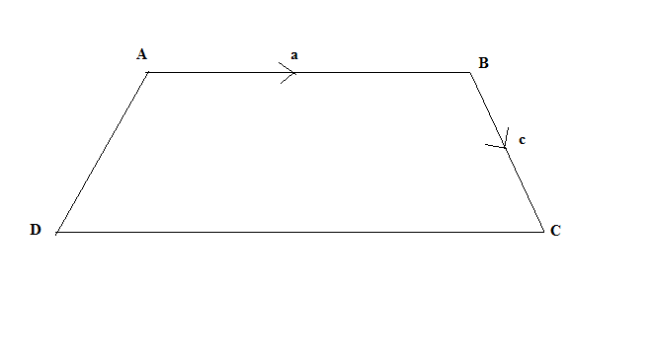
Find (i) AD (4marks)

(ii) DC in terms of $a$ and $c$ (3marks)

8.Aquantity p varies directly as the square root of r and inversely as t.When p=2,r=4
and t=3.Calculate the value of t when p=6 and r=16. (6marks)

9.Figure 2 is avenndiagram showing number of elements of sets A,B and C

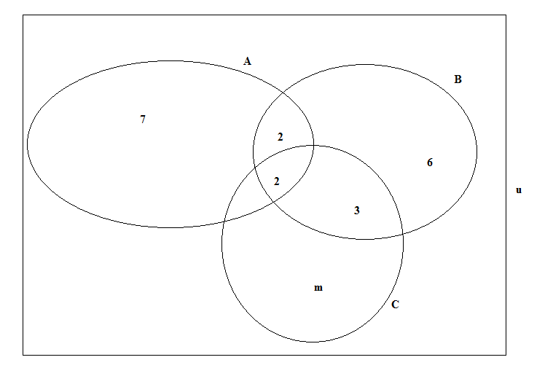
If n(AuBuC)=30,calculate the value of m (5marks)

10.The sum of 7 of the angles of a nonagon is 1000⁰.The other two angles are equal to each other. Calculate the size of other two angles. (6marks)

11.Prove that tangents from an external point drawn to the same circle are equal in length. (7marks)

12.The following marks were obtained by a class of 20 students in atest,marked out of 30
22 30 12 15 10
15 23 19 26 16
3 20 28 10 11
9 17 18 24 14
Taking 0 as the lowest class limit and using a class width of 10, construct a grouped frequency distribution table for the marks (4marks)

13.Given that ${alog}_{8^{2}}$=6 ,calculate the value$a$ (5marks)

14. Table 1 shows the speed of a train recorded every 10 seconds.
SPEED (m/s) 200 400 600 800
TIME (s) 10 20 30 40

Using a scale of 2 cm to represent 100m s ⁄ on the vertical axis and 2 cm to represent 10 seconds on the horizontal axis, draw a speed-time graph and use it to calculate the acceleration of the train. (6 marks)

15.Given that 5$\left(\begin{matrix}1 & 4 \\ 3-n & 8\end{matrix}\right)=\left(\begin{matrix}5 & 20 \\ -15 & 40\end{matrix}\right)$,find the value of n (4marks)

16.Evaluate $\frac{ab-b}{{ab}^{2}}$ when $a$=2,and $b$=-5 (4marks)

17.Figure below shows acircle JKLM, NMP is a tangent to the circle at M and NJL
is astraight line.
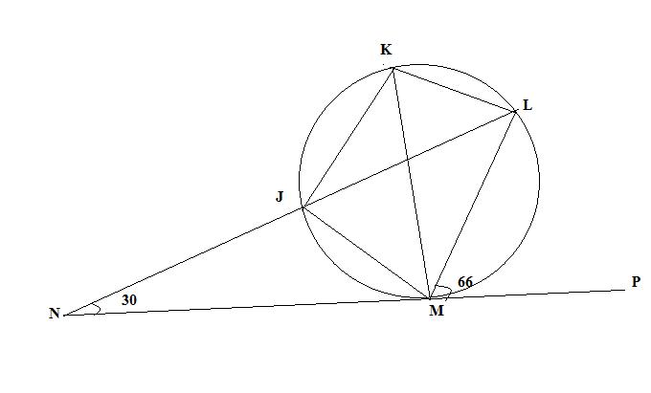
calculate angle JML (6marks)

19. A pond 12m in diameter, has a shape of a hemisphere and is full of water. The pond is emptied and all the water poured into a cylindrical tank of radius 5m. Assuming there is no loss of water, calculate the height of water in the tank.
(volume of sphere =$\frac{4}{3}{Hr}^{3}$) (6marks)

20. Using a ruler and pair of compasses only, draw a line 𝐀𝐁 = 10cm and construct a circle with the line AB as a diameter. Mark a point C on the circle such that 𝐀𝐂=6cm. Join AC and BC. Construct a tangent CP such that angle BCP is acute.
(5 marks)

END OF QUESTION PAPER

